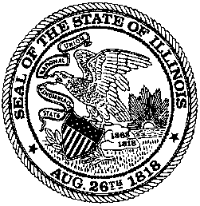

OFFICE OF THE SECRETARY OF STATE

SPRINGFIELD, ILLINOIS 62756

JESSE WHITE
SECRETARY OF STATE

** IMPORTANT **
** PLEASE READ IMMEDIATELY **

All licensees that participate in the Temporary Registration Permit (TRP’s) system and issue TRP’s to purchasers of vehicles from the licensees’s established place of business shall note that the Secretary of State has begun implementing a new, electronic auditing process of the TRP system. Any licensee found abusing or manipulating the TRP system shall find access to the TRP system revoked until the Secretary of State is satisfied that the situation is recitified. This also pertains to the issuance of the 7-day and 30-day drive away permits as well.

UNDER NO CIRCUMSTANCES, shall names, addresses, vehicle information, including VIN’s, be altered, rearranged, or otherwise manipulated in any form to fabricate or issue multiple TRP’s or 7/30-day permits to the same customer and vehicle.

FAILURE to enter a TRP or permit and allowing a customer to use a TRP or permit that has not been properly issued could result in the revocation of access to the TRP/ permit system and possible civil litigation by the customer.

In addition, no dealer or wholesaler, whether licensed by Illinois or another jurisdiction, should be issued a TRP, 7-day permit, or a 30-day drive away permit. All vehicles sold to dealers and/or wholesalers should be removed from the licensees’s premises with dealer plates, in-transit plates, or by trailer.

Any vehicle sold to an out-of-state dealer or wholesaler that is sold directly to an Illinois resident will be investigated for failure to obtain an Illinois dealer’s license.

Violations of the TRP system, including the 7 & 30-day permits, shall result in the suspension of access to the TRP system, at minimum, and may include additional penalties as well.

