[DEADLINE TO SIGN ON: COB 9/5/2025]

September XX, 2025

The Honorable John Boozman
Chairman, Senate Committee on Agriculture, Nutrition, & Forestry
United States Senate
555 Dirksen Senate Office Building
Washington. DC 20510

The Honorable Amy Klobuchar
Ranking Member, Senate Committee on Agriculture, Nutrition, & Forestry
United States Senate
425 Dirksen Senate Office Building
Washington. DC 20510
Cc: Members of the Senate Committee on Agriculture, Nutrition, & Forestry.

Dear Chairman Boozman, Ranking Member Klobuchar, and members of the Senate Committee on Agriculture, Nutrition, & Forestry:
On behalf of the California Fire Service, we are writing to express our strong support for S. 1462 the Fix Our Forests Act. This legislation represents a critical step toward advancing wildfire prevention, improving fire response capabilities, and enhancing community resilience across the nation.

As the Western United States continues to experience unprecedented wildfire seasons, we recognize the urgent need for comprehensive and coordinated federal action. The status quo is completely untenable as our local, state, and federal systems are overwhelmed. The Fix Our Forests Act will help address some of the most pressing challenges facing our landscapes and communities by:
- Accelerating landscape-scale restoration work through revised categorical exclusion (CE) and permitting thresholds that reduce delays and promote proactive land management. We need your support to enable mitigation work that can be implemented on a large enough scale to make a difference. Landscape-scale fuels treatments and strategic fuelbreaks in the Wildland Urban Interface (WUI) across vegetation types can be the difference between a community or precious wildland area surviving a fire or being lost. The status quo on permitting is no longer tenable. We must expedite these interventions, and the Fix Our Forests Act will enable us to work with our Federal partners on getting this work done.
- Driving data-informed decision-making by improving access to intelligence and leveraging existing decision support tools and data infrastructure. With the Wildfire Intelligence Center, we can ensure states and local departments can better coordinate with the federal government and achieve real-time situational awareness.
- Leveraging innovative technologies to enhance wildfire response, including the integration and accessibility of commercially available tools at both federal and state levels.
- Promoting resilience in the built environment by creating a Community Wildfire Risk Reduction Program and expanding Community Wildfire Defense Grants to include home hardening activities.
We are greatly impressed by the collaborative nature of this legislation and the commitment it reflects to bipartisan solutions that empower local, state, and federal partners alike. We understand that the Senate has emerged with a refined product through tireless bipartisan negotiations, and we commend the ongoing dialogue and thoughtful engagement with stakeholders.
We thank you for your leadership and vision in bringing forward this critical legislation. As leaders of several at-risk jurisdictions within the state, we stand ready to support the implementation of policies that strengthen our ability to protect lives, property, and the natural environment.

Sincerely,

________________________ | ________________________ | ________________________
Chief Brian Fennessy  Orange County Fire Authority | Chief Dustin Gardner  Ventura County Fire District | Chief Dan Munsey  San Bernardino County Fire Protection District
 | 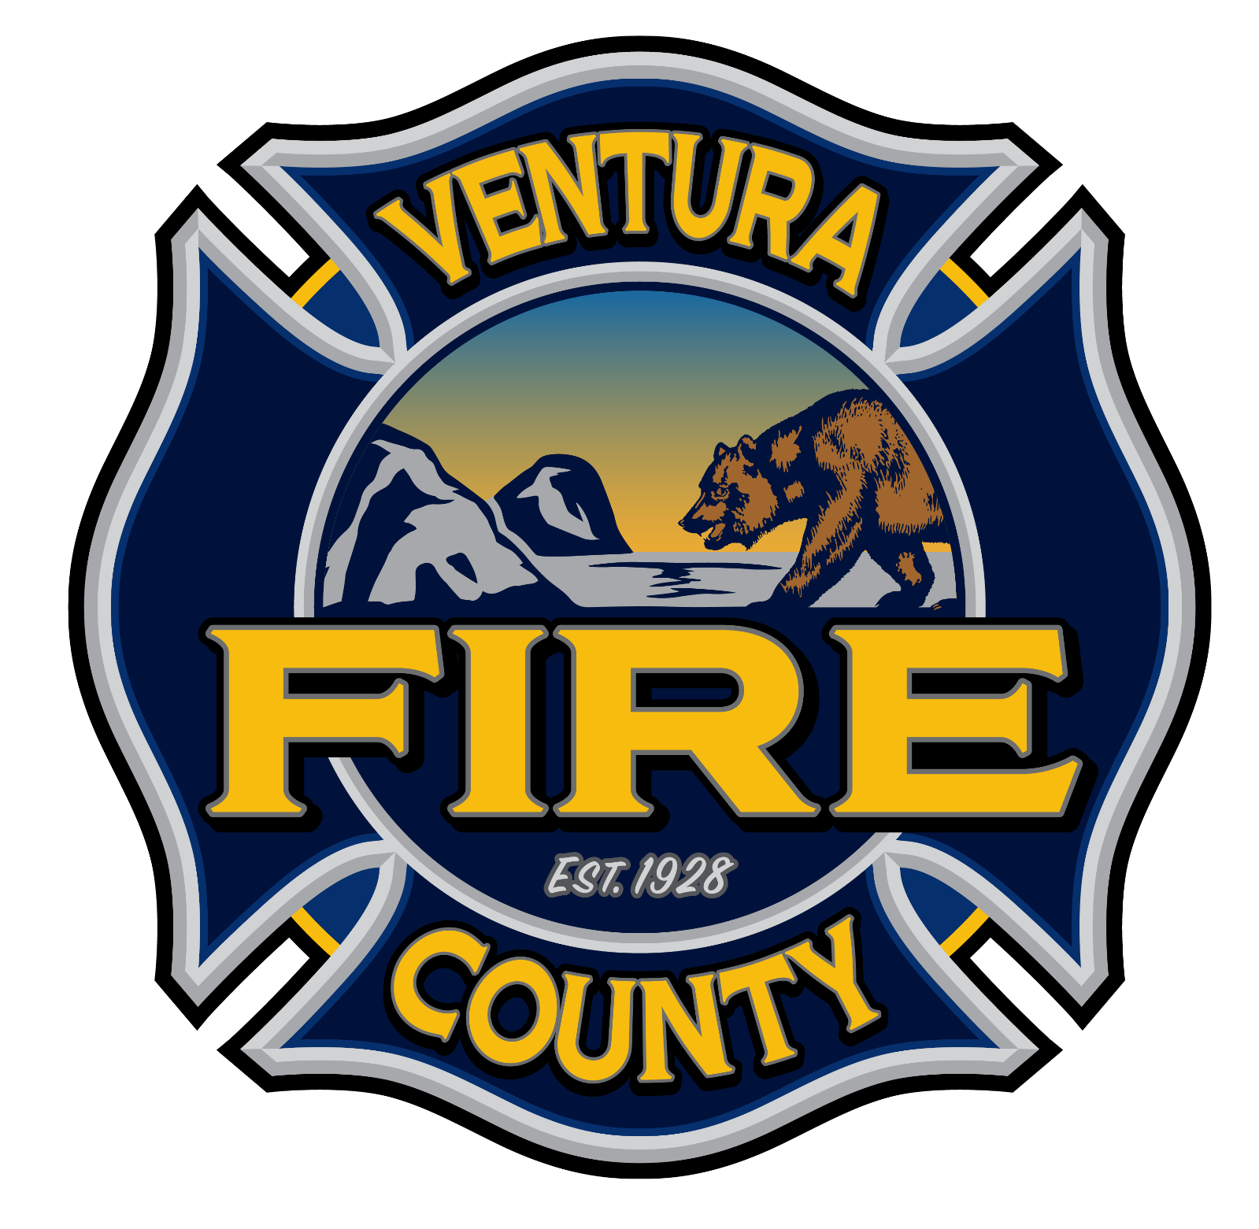 | 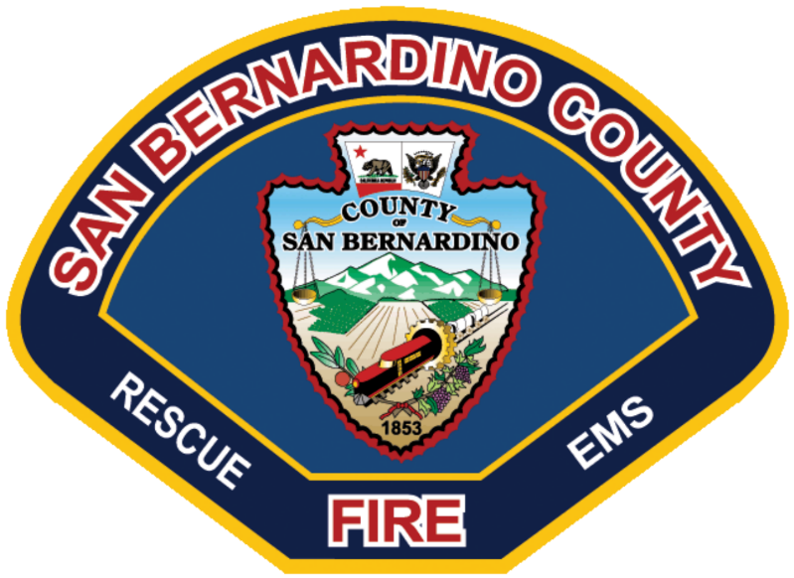

Additional California Fire Chiefs in Support of the Fix Our Forests Act:
Suwanna L. Kerdkaew  Fire Chief, Santa Clara County Fire District  1315 Dell Avenue  Campbell CA 95008 | Robert Logan  Fire Chief, City of San Diego  Fire-Rescue Department  600 B St., Suite 1300  San Diego, CA 92101
Christian Tubbs  Fire Chief, Southern Marin Fire District  28 Liberty Ship Way, Suite 2800  Sausalito, CA 94965 | <Chief Name>  Title, District  Agency/District Address
<Chief Name>  Title, District  Agency/District Address | <Chief Name>  Title, District  Agency/District Address
<Chief Name>  Title, District  Agency/District Address | <Chief Name>  Title, District  Agency/District Address
<Chief Name>  Title, District  Agency/District Address | <Chief Name>  Title, District  Agency/District Address
<Chief Name>  Title, District  Agency/District Address | <Chief Name>  Title, District  Agency/District Address
<Chief Name>  Title, District  Agency/District Address | <Chief Name>  Title, District  Agency/District Address
<Chief Name>  Title, District  Agency/District Address | <Chief Name>  Title, District  Agency/District Address
<Chief Name>  Title, District  Agency/District Address | <Chief Name>  Title, District  Agency/District Address

