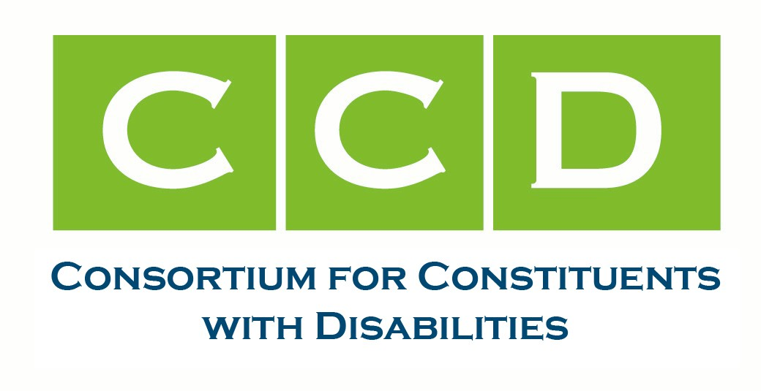

February 9, 2026

The Honorable Gus Bilirakis  House Energy & Commerce Committee  Subcommittee on Commerce, Manufacturing and Trade  2125 Rayburn House Office Building  Washington, DC 20515 | The Honorable Jan Schakowsky  House Energy & Commerce Committee  Subcommittee on Commerce, Manufacturing and Trade  2125 Rayburn House Office Building  Washington, DC 20515

RE: Letter for the Record for the Markup of “Legislation to Strengthen Motor Vehicle Safety and Advance U.S. Automotive Leadership”

Dear Chairman Bilirakis and Ranking Member Schakowsky:

The undersigned members of the Consortium for Constituents with Disabilities (CCD) Transportation Task Force and friends write to submit a letter for the record for the February 10, 2026 markup of legislation to strengthen motor vehicle safety and advance U.S. automative leadership. To allow people with disabilities to benefit from autonomous vehicles (AVs), the vehicles must accommodate passengers to remain in their personal wheelchairs, the human machine interface (HMI) must be accessible for people with sensory and cognitive disabilities, vehicles must be able to detect all types of disabled pedestrians, and disabled passengers and pedestrian’s rights and access to courts must be protected.

We acknowledge additional research into automated securement is proposed in the Motor Vehicle Modernization Act and that vulnerable road user detection, including pedestrians and wheelchair users, is proposed in the Magnus White Safe Streets for Everyone Act. We support the automated securement provision and the Magnus White bill.

Access and safety for disabled passengers is not addressed in the Safely Ensuring Lives Future Deployment and Research in Vehicle Evolution (SELF DRIVE) Act of 2026 (H.R. 7390). To ensure American leadership in AVs and automated driving system (ADS)-equipped vehicles, we urge you to prioritize the safety and access needs of disabled passengers and. Provisions that would address accessibility and safety needs are provided below and legislative text is attached. We are also attaching our letter submitted on January 14th which provides additional background.

To ensure access and safety for disabled passengers and pedestrians we urge you to:
- Prohibit licensing discrimination on the basis of disability by states and any other governmental authorities in licensing. This provision was provided in previous AV discussion drafts. Text is provided below.

  - LICENSING.—A State may not issue a motor vehicle operator’s license for the operation or use of a dedicated highly automated vehicle in a manner that discriminates on the basis of disability (as defined in section 3 of the Americans with Disabilities Act of 1990 (42 U.S.C. 12102)).

- Include rulemaking requirements for securement and ramps for wheelchair users, fully accessible HMI for people with sensory, cognitive and physical disabilities, and ADS detection and response ensuring the vehicle can detect wheelchair and service animal users. Research alone into wheelchair securement systems does not ensure a future for wheelchair users to independently use AVs. We urge the committee to include language that requires rulemaking for wheelchair securement systems. Draft legislative text for accessibility rulemaking provisions is provided in the attached Disability Access in AVs and Motor Vehicles draft bill for your consideration.

- Prohibit discrimination on the basis of disability by transportation service providers, including AV companies offering on demand or taxi-like services. Discrimination could include not providing wheelchair accessible options or for other people with disabilities, and not providing service in a timely manner comparable to services provided to ambulatory users. Draft legislative text prohibiting discrimination is provided in the attached Disability Access in AVs and Motor Vehicles draft bill for your consideration.

- Limit forced arbitration for disabled passengers and pedestrians. AV providers must be held accountable for injuries and property damage, and remedies available under applicable civil rights laws must be made available. Disabled passengers repeatedly face discrimination from rideshare and micromobility services and disabled pedestrians and cyclists routinely have dangerous interactions with vehicles in public streets and rights of way. The rights of disabled travelers should be protected to ensure a safe and quality experience. To fully protect their rights, all disabled people must have the option to take their claims, including those under civil rights laws and the Americans with Disabilities Act, to court. Should forced arbitration be allowed, we urge upholding disabled travelers’ rights. Draft legislative text prohibiting discrimination is provided in the attached Disability Access in AVs and Motor Vehicles draft bill for your consideration.

We also encourage consideration of the following:

- Inclusion of an AV Advisory Council that includes disability, industry and other stakeholders to continue discussions and solution finding for safety, accessibility and other issues;
- Accessibility of vehicles required in any safety case or safety standards;
- Disability needs considered in FMVSS updates;
- Reporting of injury, harm or death of disabled passengers and pedestrians, or their service animals or assistive devices, in crash reporting;
- Language that ensures disabled people’s rights are upheld when they or their devices or animals are harmed, or they are discriminated against;
- Funding and resources for U.S. Department of Transportation and U.S. Access Board staff to implement AV safety and accessibility rulemaking, research and programming;
- Collection and sharing of infrastructure data such as curb ramps and accessibility of sidewalks to ensure safety and accessibility for disabled passengers; and
- Provisions to ensure privacy of disabled passengers and pedestrians and their data.

Thank you for your consideration. Please contact CT Tyson at ctyson@dredf.org and Sarah Malaier at smalaier@afb.org with any questions. We are eager to support your eﬀorts to enhance safety and mobility for all.

Sincerely,

CCD Transportation Task Force Co-Chairs

Danica Gonzalves, Paralyzed Veterans of America, danicag@pva.org
Sarah Malaier, American Foundation for the Blind, smalaier@afb.org
Tyler Beck, Epilepsy Foundation of America, tbeck@efga.org

Signatory Organizations

Access Ready
American Association of People with Disabilities
American Council of the Blind
American Foundation for the Blind
American Printing House for the Blind
Autistic Women & Nonbinary Network
Christopher & Dana Reeves Foundation
Deaf Equality
Disability Belongs
Disability Rights California
Disability Rights Education & Defense Fund
Easterseals
Epilepsy Foundation of America
Muscular Dystrophy Association
National Council on Independent Living
National Disability Institute
Paralyzed Veterans of America
TDIforAccess
United Spinal Association
###

CCD is the largest coalition of national organizations working together to advocate for Federal public policy that ensures the self-determination, independence, empowerment, integration and inclusion of people with disabilities. The Americans with Disabilities Act (ADA) sought to “provide a clear and comprehensive national mandate for the elimination of discrimination against individuals with disabilities.” Through AV policymaking, Congress has the opportunity to lead, uphold the ADA’s mandate, enhance safety, and improve lives and mobility for all.

cc: Energy and Commerce Committee Chairman Guthrie, Ranking Member Pallone and all members of the Committee.

We support provisions prohibiting some predispute arbitration claims. We also encourage remedies available under applicable civil rights laws be included.

